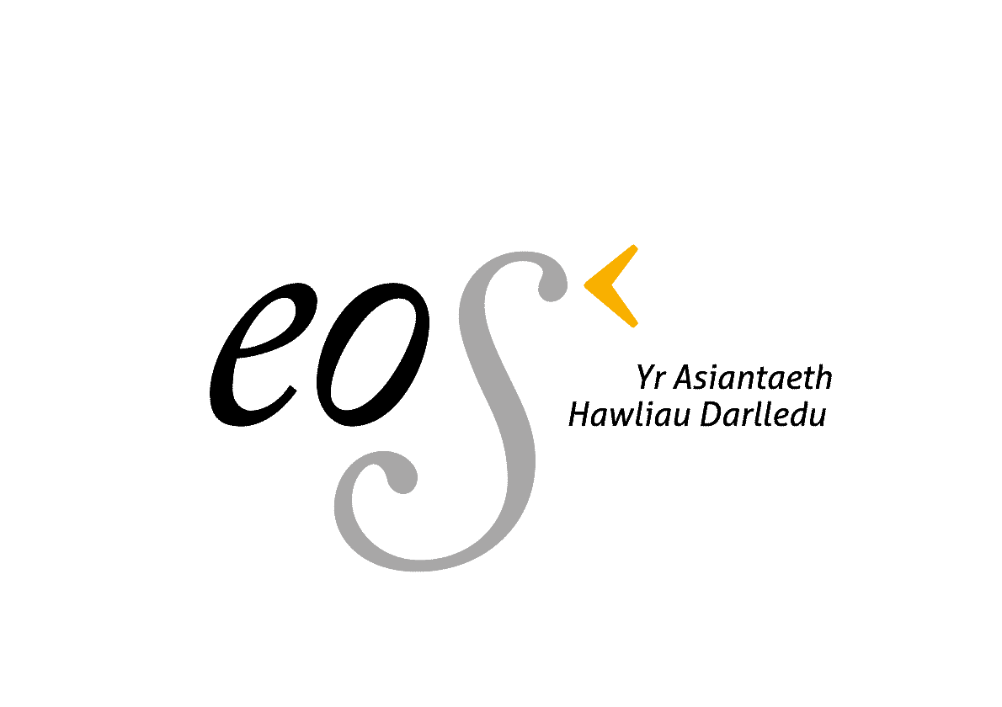

Ail aseinio eich hawliau Darlledu a Theledu.

1. Tynnu eich hawliau i ffwrdd o PRS – Withdrawing your rights from PRS

Arwyddwch y llythyr ar dudalen 2.
Sign the letter on page 2.

- 2. Ymuno gydag Eos – Joining Eos

Llenwch ac arwyddwch y cytundeb aelodaeth Eos sydd ar dudalen 3 (Cymraeg)

Complete and sign the Eos membership contract o page 4 (English)

3. Manylion Cyswllt / Contact Details

Cwblhewch y tabl ar dudalen 5.
Complete the table on page 5.

4.

Gyrrwch pob tudalen sydd wedi’i gwblhau / arwyddo i swyddfa Eos.
Send all signed forms to Eos’ office.
Eos – Yr Asiantaeth Hawliau Darlledu Cyf
Canolfan Sain
Llandwrog
Caernarfon
Gwynedd
LL54 5TG

Diolch yn fawr,
Tomos I Jones
Eos
01286 832110
gweinyddyddeos@gmail.com

www.eoscymru.com

Date:

PRS for Music
41 Streatham High Road
London
SW16 1ER

FAO: Legal Dept - Karen Fishman, Senior Corporate Counsel

Dear Sirs,

PRS Article 9(f)(i)(c) - Notice of requirement for Assignment of Rights

I/We the undersigned, as a member of PRS, hereby give notice to PRS that I/we require you to assign to me/us in respect of all works in which I am/we are on the date of this notice and may during the period of my/our membership become interested as [writer,][publisher] [and/or] [proprietor] and whether or not such works are now or in the future notified by me/us to PRS, the following forms of utilisation of the rights specified in Article 7(cd) of your Constitution for the territory of the United Kingdom only:-

the “broadcasting right”; and

the “televising right”.

I/We understand:
- that this notice will take effect from the later of: December 31st 2023 and the expiry of three calendar months from the date of on which notice is given.

Sincerely,

Signed: ______________________

Name: ______________________

CAE No.:_____________________

(On behalf of: _____________________________________ Publishing Company)

Eos – Yr Asiantaeth Hawliau Darlledu Cyf
Canolfan Sain, Llandwrog, Caernarfon, Gwynedd, LL54 5TG

Swyddfa Eos 01286 832110
gweinyddyddeos@gmail.com

Cytundeb rhwng

Eos – Yr Asiantaeth Hawliau Darlledu Cyf. (“Yr Asiantaeth”)

a

. . . . . . . . . . . . . . . . . . . . . . . . . . . . . . . . . . . . . (“Yr Aelod”)
(eich enw chi neu enw'r cwmni rydych chi'n ei gynrychioli)

Daw'r cytundeb hwn i rym ar 01/01/2024

Gall y naill barti neu'r llall derfynu'r cytundeb hwn ar ôl rhoi 7 diwrnod o rybudd i’r parti arall.

Mae'r Aelod yn aseinio i'r Asiantaeth, ar gyfer ac yn ystod y cyfnod o aelodaeth, yr hawliau darlledu a thelediadau sydd yn yr holl weithiau cerddorol sydd o eiddo’r Aelod.

Mae'r Aelod yn rhoi i'r Asiantaeth, ar gyfer ac yn ystod y cyfnod o aelodaeth, yn ei enw ei hun neu yn un Yr Asiantaeth ond ar draul Yr Asiantaeth yn unig, y pŵer a'r awdurdod i:

i) awdurdodi neu ganiatáu neu wahardd arfer yr hawliau sydd i'w gweinyddu gan Yr Asiantaeth ar ran Yr Aelod;

ii) i roi trwyddedau ar ei ran ar gyfer arfer hawliau o'r fath;

iii) i gasglu ffioedd, tanysgrifiadau, neu arian ar gyfer defnydd awdurdodedig hawliau darlledu unrhyw un o weithiau'r Aelod, neu ar ffurf iawndal ar gyfer defnydd heb ganiatád o hawliau darlledu gweithiau o'r fath;

iv) i gychwyn ac erlyn achos yn erbyn pob person sy'n amharu ar yr hawliau hyn, ac, yn ôl disgresiwn Yr Asiantaeth, i amddiffyn neu wrthwynebu unrhyw achos a gymerir yn erbyn unrhyw Aelod o ran hawliau o'r fath ac i ddwysáu, cyfaddawdu, cyfeirio at gyflafareddu neu ddarostwng i ddyfarniad mewn unrhyw achos o'r fath, ac yn gyffredinol i gynrychioli'r Aelod ym mhob mater sy'n ymwneud â'i hawliau;

v) i amddiffyn yn gyffredinol y cyfryw hawliau yng ngweithiau'r Aelod hwnnw;

vi) i ddirprwyo'r awdurdod i wneud fel y disgrifiwyd uchod i drydydd parti at y diben o arfer hawliau'r Aelod.

Llofnod . . . . . . . . . . . . . . . . . . . . . . . . . . . . . . . . . . . . . . . . Dyddiad . . . . . . . . . . .
(Yr Aelod neu gynrychiolydd ar ran y cwmni)

Llofnod . . . . . . . . . . . . . . . . . . . . . . . . . . . . . . . . . . . . . . . . Dyddiad . . . . . . . . . . .
(ar ran Yr Asiantaeth)

Contract between

Eos – Yr Asiantaeth Hawliau Darlledu Cyf (The Agency)

And
………………………………………………………………………………. (The Member)
(your name / the name of the company you represent)

This contract comes into effect on 01/01/2024

Either party may terminate this contract subject to 7 days prior warning to respective parties.

The member grants to the Agency, for and during the period of membership, full ownership of the broadcasting and televising rights in all of the musical works owned by the Member.

The Member, by virtue of his election, grants to the Agency, for and during the period of membership, in his name or in that of the Agency but at the Agency’s sole charge and expense, the sole power and authority:-

- to authorise or permit or forbid the exercise of the rights to be administered by the Agency on behalf of the Member;

- to grant licences on his/hers behalf for the exercise of such rights;

- to collect fees, subscriptions, or monies whether for the authorised use of any of the Member’s works, or by way of damages or compensation for the unauthorised use of such works;

- to institute and prosecute proceedings against all persons infringing the said rights and, if the Agency in its discretion thinks fit, to defend or oppose any proceedings taken against any Member in respect of such rights and to compound, compromise, refer to arbitration or submit to judgement in any such proceedings, and generally to represent the Member in all matters concerning the said rights;

- to protect generally the said rights in the Member’s works;

- to delegate authority to do any acts as aforesaid to any affiliated society and to any agent or representative, for the purpose of exercising the said rights.

Signature………………………………………………… Date…………………… (The Member or representative on behalf of the company)

Signature………………………………………………… Date…………………… (on behalf of the Agency)
Eos – Yr Asiantaeth Hawliau Darlledu Cyf
Canolfan Sain, Llandwrog, Caernarfon, Gwynedd, LL54 5TG

Swyddfa Eos 01286 832110
gweinyddyddeos@gmail.com

MANYLION PERSONOL / PERSONAL DETAILS

ENW LLAWN / FULL NAME:

CYFEIRIAD / ADDRESS:

RHIF FFÔN CARTREF / HOME PHONE NUMBER:
RHIF FFÔN SYMUDOL / MOBILE NUMBER:

E-BOST / EMAIL:

CYHOEDDWYR / PUBLISHER:

RHIF AELODAETH PRS
(CAE):

Wrth dicio'r blwch hwn, rwyf yn caniatáu Eos i gysylltu â mi am faterion yn ymwneud â'r asiantaeth.

By ticking this box, I consent to Eos contacting me on matters relating to the organisation.

Dewisiadau Cyswllt // Contact Preferences

Ticiwch fel y bo’n briodol. // Please tick as appropriate.

Ebost / Email
Ffôn/ Phone
Post

