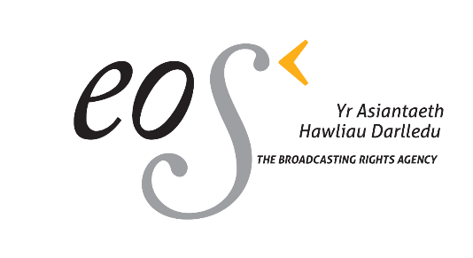

Eos – The Broadcasting Rights Agency

Canolfan Sain, Llandwrog, Caernarfon, Gwynedd, LL54 5TG

Adminisrator Office 01286 832110
gweinyddyddeos@gmail.com

MEMBER INFORMATION FORM

FULL NAME:

ADDRESS:
PHONE NUMBER - MOBILE AND
LANDINE:

E-MAIL:

NAME / NAMES ON
WORKS:

ALIAS / ALIASES:

BAND / BANDS:

PUBLISHER /
PUBLISHERS:

PRS MEMBERSHIP NUMBER
(CAE):

NAME ON BANK ACCOUNT:

ACCOUNT NUMBER:

SORT CODE:

NAME OF BANK:

